

# (B.TECH) Semester-VII AY 2023-24

**DL Lab Assignment No. 03**

|  |  |
| --- | --- |
| **Student Name: Rohit Saini____________________** | **PRN No.:1032200897** |
| **Date: 06-10-2023** | **Faculty: Prof. Anita Gunjal** |

**Problem Statement:** To implement the Graph in TensorBoard.

**Objectives:**

1. To implement simple addition or multiplication operation using tensor and it’s the graph representation with TensorBoard.

**Theory:** (describe the following)

* TensorBoard and visualization Analysis

TensorBoard is a powerful visualization tool and analysis platform developed by Google as part of the TensorFlow ecosystem. It is primarily used for monitoring and visualizing various aspects of machine learning experiments and deep learning models. TensorBoard provides a user-friendly interface to help researchers and developers gain insights into their models, track training progress, and make informed decisions about model improvements. Here's a breakdown of what TensorBoard offers:

* **Visualization of Scalars:** TensorBoard allows you to track and visualize scalar values over time, such as loss, accuracy, or custom metrics. You can view these metrics as interactive plots to understand how your model's performance changes during training.
* **Graph Visualization:** One of TensorBoard's most essential features is the ability to visualize the computational graph of your deep learning model. This graph provides a detailed overview of the model's architecture, making it easier to understand and debug complex networks.
* **Histograms and Distributions:** You can inspect the distributions of weights and biases in your neural network layers using histograms. This is valuable for identifying issues like vanishing or exploding gradients during training.
* **Embeddings:** TensorBoard allows you to visualize high-dimensional data using dimensionality reduction techniques like Principal Component Analysis (PCA) or t-SNE. This can be helpful when working with embeddings, such as word embeddings or feature embeddings in neural networks.
* **Image Summaries**: For computer vision tasks, TensorBoard can display image summaries, helping you visualize input images, ground truth labels, and model predictions side by side.

# Operations to be performed:

1. Implement few examples using TensorFlow.
2. Perform a simple operation using TensorBoard

# Program code:

**`**

**Output: (paste output screen & graphs plotted)**

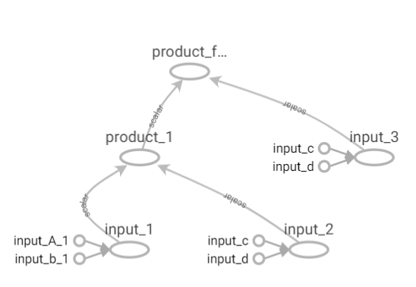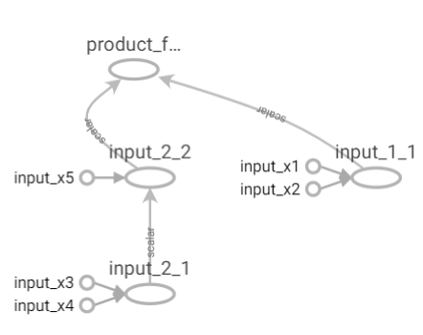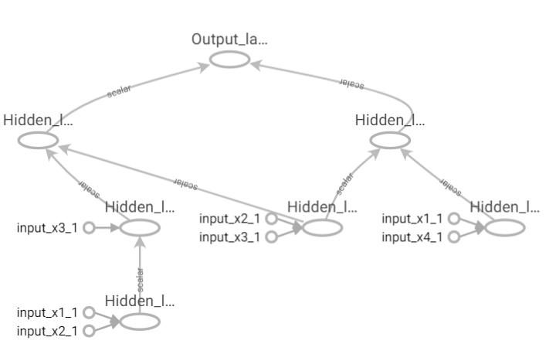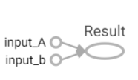

# FAQs:

1. Mention the advantages of analyzing the operations using TensorBoard.
2. Why there’s a need for the two phases in Classic Tensorflow?
3. Which are the three main methods of getting data into a TensorFlow program?
4. State the significance of Event logger.
5. Explain the terms with the help of examples:
   1. Constant
   2. Variable
   3. Placeholder
   4. Tensor
   5. Session

# Conclusion:

The graph representation with TensorBoard was performed successfully. 